SDG&E Comments:

BPM Section 5.3.1 was the only remaining area of comment for PRR 1186.

cid:image001.png@01D58432.6E15A080

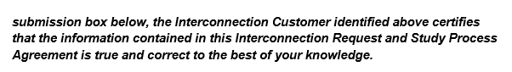

It would seem that the IC attestation should be consistent in either using “my name” and “my knowledge,”

Or “your name” and “your knowledge.”

Below is the recommendation from SDG&E:

